ZOCS Virtual Learning Environment (VLE) User Manual

# Introduction

Welcome to the ZOCS Virtual Learning Environment (VLE), a platform designed to facilitate online education and collaboration among various stakeholders in the Early Childhood Learning (ECL) ecosystem. This user manual provides detailed instructions for different user roles within the system: Admin, Zocs User, Ministry of Education, District Manager, Teacher, and Parent.

This user manual provides a comprehensive guide to the VLE platform, outlining the functionalities and features available to different user types.

## Logging In

Before you begin, all users need to log in to the VLE using their unique username and password. Upon successful login, the system will display your respective dashboard. For new users without an account, seek the guidance of the system administrator or a respective user as guided below.

# User Roles and Dashboards

The VLE caters to various user roles, each with a designated dashboard offering a personalized view of the platform. Let's explore the functionalities for each user type:

### **Admin User:**

1. **Dashboard:** The main page provides an overview of the system, including summaries of schools, users, and recent blogs. On the side you’ll see a navigation menu to take you to various pages as seen below.

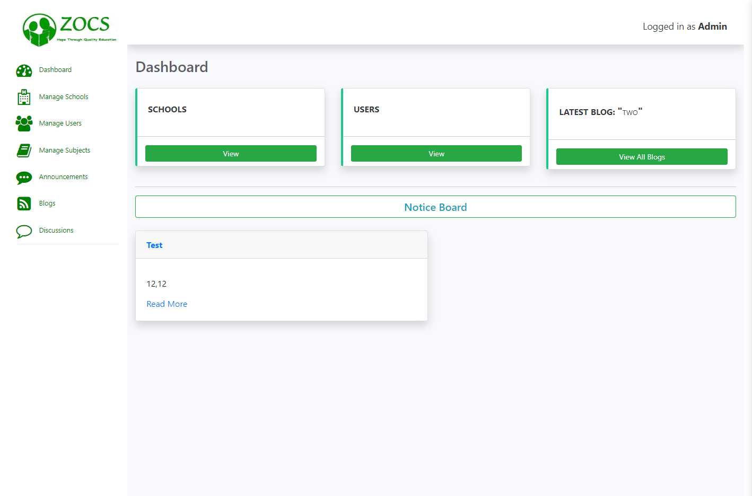

1. **Manage Schools:** Here you get to view and manage all schools within the system, including adding, editing, or deleting school profiles. When creating a new school, the user can either manually enter the school coordinates or locate it on the map to show its precise location.

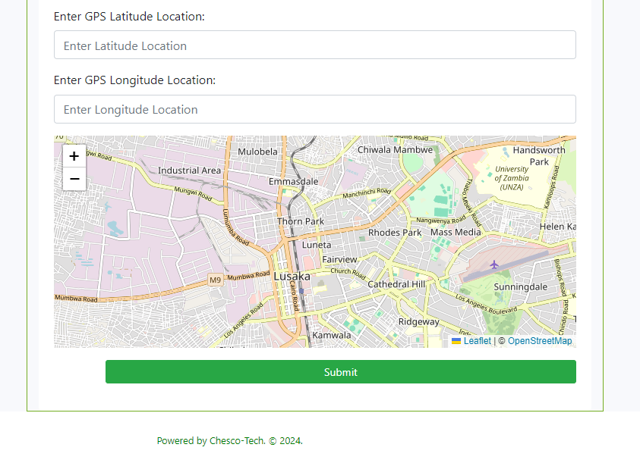

1. **Manage Users:** Handle all user-related tasks, such as adding, editing, or deleting user accounts, and assigning user roles, i.e. Ministry of Education user, ZOCS user, etc.
2. **Manage Subjects:** Control the subjects available in the system, including adding, editing, or deleting subject profiles.
3. **Announcemen**ts: View and create important announcements or notifications for all users. Additionally, you can set the user type you are making the announcement to, to limit the announcement’s audience.
4. **Blogs:** Create and access and manage all published news blogs within the system.
5. **Discussions:** Engage in online discussions and moderate user interactions.
6. **Notice Board:** Displays critical notices or updates created by various users, i.e. ZOCS users, District Admin, etc.

### **Zocs User:**

1. **Dashboard:** Provides an overview of the platform's functionalities available to the ZOCS users.
2. **Manage Schools:** Add, edit, or delete school profiles. (Refer to point number 2 under Admin above).
3. **Manage Users:** Handle user accounts and permissions. (Refer to point number 2 under Admin above).
4. **Queries:** Access and manage user inquiries or support tickets created by teachers. Here you can see query ID, query description, the teacher who created the query, the school from which it was created, file attachment, if available.
5. **View PTA Notices:** Review the latest notices from the Parent-Teacher Association.
6. **Announcements:** View important announcements and updates from various users and create your own. By default, the announcements you create are seen by all users, if you wish for the announcement to be visible to a specific user type, click on the “Audience” dropdown shown below and select the user type you wish to target.

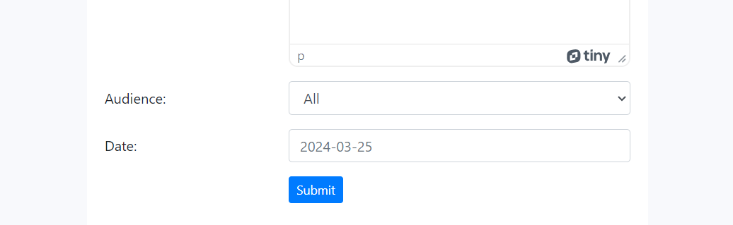

1. **E-Files:** Access electronic documents and resources. Here you also have an option to add your own file by clicking “ADD DOCUMENT” button. When adding your document you get to set visibility to public, for the document to Be accessed by anyone on the internet, or private-only you and the admins.
2. **Blogs:** Read published blogs or create new posts.
3. **Discussions:** Participate in forum discussions or start new topics.

### **Ministry of Education:**

1. **Dashboard:** Overview of the platform, including recent announcements and quick links.
2. **Manage Teachers:** View and manage teacher accounts and permissions. Create new teachers and assign them to schools.
3. **E-Files:** Access electronic documents and resources relevant to the Ministry's role. Here you also have an option to add your own file by clicking “ADD DOCUMENT” button. When adding your document you get to set visibility to public, for the document to be accessed by anyone on the internet, or private-only you and the admins.
4. **Announcements:** View important updates and news from the institution. (Refer to point number 6 under Zocs User above).
5. **Discussions:** Participate in online forums and discussions with other users.

### **District Manager:**

1. **Dashboard:** Overview of system functions.
2. **Manage Teachers:** Add, edit, or delete teacher accounts. (Refer to point number 2 under Ministry of Education User above).
3. **Schools in District:** View, add, edit, or delete school profiles in the user’s respective district. (Refer to point number 2 under Admin above).
4. **Queries:** Access and manage user inquiries or support tickets created by teachers. Here you can see query ID, query description, the teacher who created the query, the school from which it was created, file attachment, if available.
5. **Announcements:** View important updates and news from the institution. (Refer to point number 6 under Zocs User above).
6. **Discussions:** Monitor and participate in forum discussions.
7. **Enrollment:** To view school enrollment reports, on the enrollments page select a school on top at “Select School” and the report will show up in the table as shown below.

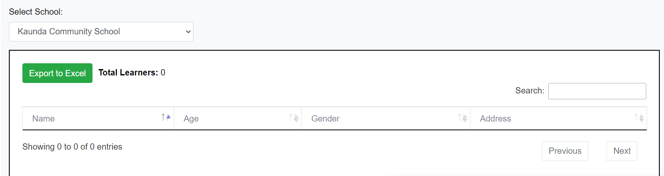

1. **Blogs:** Read published blogs or create new posts.
2. **Zones:** View and create new Zones in the user’s respective District and participate in Zone discussions within those Zones.

### **Teacher:**

1. **Dashboard:** Displays an overview of user’s classes, subjects, and messages.
2. **My Classes:** View and manage a list of classes you are teaching.
3. **My Subjects:** View and manage a list of subjects you are teaching.
4. **Parents:** List and CRUD (Create, Read, Update, Delete) all parents of the students you are teaching. When creating a Parent’s account there is an option to select whether a parent is a PTA chair/representative or not.

1. **Zone Discussions:** Start and participate in discussions within your zone.
2. **Message Parent:** Contact parents privately to discuss school related matters regarding their kids, homework, etc.
3. **VLE-Learning:** Access the main learning platform with various resources.

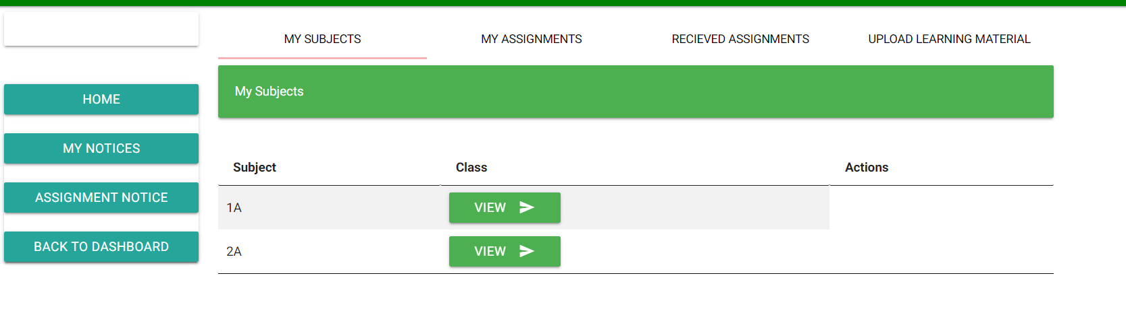

# Conclusion

This user manual aims to provide comprehensive guidance on navigating and utilizing the VLE platform effectively according to your respective roles. Should you encounter any issues or require further assistance, please refer to the platform's support resources or contact your system administrator for help. Happy learning and collaboration!